Software Environment

Java Technology

Java technology is both a programming language and a platform.

The Java Programming Language

The Java programming language is a high-level language that can be characterized by all of the following buzzwords:

    - Simple
    - Architecture neutral
    - Object oriented
    - Portable
    - Distributed
    - High performance
    - Interpreted
    - Multithreaded
    - Robust
    - Dynamic
    - Secure

With most programming languages, you either compile or interpret a program so that you can run it on your computer. The Java programming language is unusual in that a program is both compiled and interpreted. With the compiler, first you translate a program into an intermediate language called Java byte codes —the platform-independent codes interpreted by the interpreter on the Java platform. The interpreter parses and runs each Java byte code instruction on the computer. Compilation happens just once; interpretation occurs each time the program is executed. The following figure illustrates how this works.

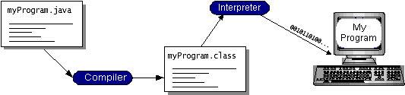

You can think of Java byte codes as the machine code instructions for the Java Virtual Machine (Java VM). Every Java interpreter, whether it’s a development tool or a Web browser that can run applets, is an implementation of the Java VM. Java byte codes help make “write once, run anywhere” possible. You can compile your program into byte codes on any platform that has a Java compiler. The byte codes can then be run on any implementation of the Java VM. That means that as long as a computer has a Java VM, the same program written in the Java programming language can run on Windows 2000, a Solaris workstation, or on an iMac.

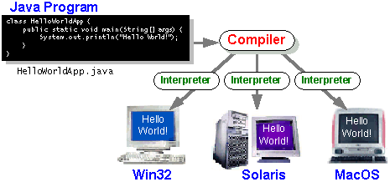

The Java Platform
A platform is the hardware or software environment in which a program runs. We’ve already mentioned some of the most popular platforms like Windows 2000, Linux, Solaris, and MacOS. Most platforms can be described as a combination of the operating system and hardware. The Java platform differs from most other platforms in that it’s a software-only platform that runs on top of other hardware-based platforms.
The Java platform has two components:
- The Java Virtual Machine (Java VM)
- The Java Application Programming Interface (Java API)
You’ve already been introduced to the Java VM. It’s the base for the Java platform and is ported onto various hardware-based platforms.
The Java API is a large collection of ready-made software components that provide many useful capabilities, such as graphical user interface (GUI) widgets. The Java API is grouped into libraries of related classes and interfaces; these libraries are known as packages. The next section, What Can Java Technology Do? Highlights what functionality some of the packages in the Java API provide.
The following figure depicts a program that’s running on the Java platform. As the figure shows, the Java API and the virtual machine insulate the program from the hardware.
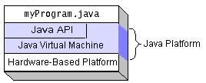
Native code is code that after you compile it, the compiled code runs on a specific hardware platform. As a platform-independent environment, the Java platform can be a bit slower than native code. However, smart compilers, well-tuned interpreters, and just-in-time byte code compilers can bring performance close to that of native code without threatening portability.

What Can Java Technology Do?
The most common types of programs written in the Java programming language are applets and applications. If you’ve surfed the Web, you’re probably already familiar with applets. An applet is a program that adheres to certain conventions that allow it to run within a Java-enabled browser.
However, the Java programming language is not just for writing cute, entertaining applets for the Web. The general-purpose, high-level Java programming language is also a powerful software platform. Using the generous API, you can write many types of programs.
An application is a standalone program that runs directly on the Java platform. A special kind of application known as a server serves and supports clients on a network. Examples of servers are Web servers, proxy servers, mail servers, and print servers. Another specialized program is a servlet. A servlet can almost be thought of as an applet that runs on the server side. Java Servlets are a popular choice for building interactive web applications, replacing the use of CGI scripts. Servlets are similar to applets in that they are runtime extensions of applications. Instead of working in browsers, though, servlets run within Java Web servers, configuring or tailoring the server.
How does the API support all these kinds of programs? It does so with packages of software components that provides a wide range of functionality. Every full implementation of the Java platform gives you the following features:
- The essentials: Objects, strings, threads, numbers, input and output, data structures, system properties, date and time, and so on.
- Applets: The set of conventions used by applets.
- Networking: URLs, TCP (Transmission Control Protocol), UDP (User Data gram Protocol) sockets, and IP (Internet Protocol) addresses.
- Internationalization: Help for writing programs that can be localized for users worldwide. Programs can automatically adapt to specific locales and be displayed in the appropriate language.
- Security: Both low level and high level, including electronic signatures, public and private key management, access control, and certificates.
- Software components: Known as JavaBeansTM, can plug into existing component architectures.
- Object serialization: Allows lightweight persistence and communication via Remote Method Invocation (RMI).

How Will Java Technology Change My Life?
We can’t promise you fame, fortune, or even a job if you learn the Java programming language. Still, it is likely to make your programs better and requires less effort than other languages. We believe that Java technology will help you do the following:
- Get started quickly: Although the Java programming language is a powerful object-oriented language, it’s easy to learn, especially for programmers already familiar with C or C++.
- Write less code: Comparisons of program metrics (class counts, method counts, and so on) suggest that a program written in the Java programming language can be four times smaller than the same program in C++.
- Write better code: The Java programming language encourages good coding practices, and its garbage collection helps you avoid memory leaks. Its object orientation, its JavaBeans component architecture, and its wide-ranging, easily extendible API let you reuse other people’s tested code and introduce fewer bugs.
- Develop programs more quickly: Your development time may be as much as twice as fast versus writing the same program in C++. Why? You write fewer lines of code and it is a simpler programming language than C++.
- Avoid platform dependencies with 100% Pure Java: You can keep your program portable by avoiding the use of libraries written in other languages. The 100% Pure JavaTM Product Certification Program has a repository of historical process manuals, white papers, brochures, and similar materials online.
- Write once, run anywhere: Because 100% Pure Java programs are compiled into machine-independent byte codes, they run consistently on any Java platform.
- Distribute software more easily: You can upgrade applets easily from a central server. Applets take advantage of the feature of allowing new classes to be loaded “on the fly,” without recompiling the entire program.
Java ha two things: a programming language and a platform.
Java is a high-level programming language that is all of the following
Simple Architecture-neutral
Object-oriented Portable
Distributed High-performance
Interpreted multithreaded
Robust Dynamic
Secure

Java is also unusual in that each Java program is both compiled and interpreted. With a compile you translate a Java program into an intermediate language called Java byte codes the platform-independent code instruction is passed and run on the computer.
Compilation happens just once; interpretation occurs each time the program is executed. The figure illustrates how this works.

Java Program
Compilers
Interpreter
My Program

You can think of Java byte codes as the machine code instructions for the Java Virtual Machine (Java VM). Every Java interpreter, whether it’s a Java development tool or a Web browser that can run Java applets, is an implementation of the Java VM. The Java VM can also be implemented in hardware.

Java byte codes help make “write once, run anywhere” possible. You can compile your Java program into byte codes on my platform that has a Java compiler. The byte codes can then be run any implementation of the Java VM. For example, the same Java program can run Windows NT, Solaris, and Macintosh.
Robomongo/NoSQL- Database:
Mongo DB is a cross-platform, document oriented database that provides, high performance, high availability, and easy scalability. Mongo DB works on concept of collection and document.

Database

Database is a physical container for collections. Each database gets its own set of files on the file system. A single Mongo DB server typically has multiple databases.
The advantages of NoSQL include being able to handle:

- Large volumes of structured,
- semi-structured,
- and unstructured data Agile sprints,
- quick iteration,
- and frequent code pushes Object-oriented programming that is easy to use and flexible Efficient, scale-out architecture instead of expensive, monolithic architecture

Collection

Collection is a group of MongoDB documents. It is the equivalent of an RDBMS table. A collection exists within a single database. Collections do not enforce a schema. Documents within a collection can have different fields. Typically, all documents in a collection are of similar or related purpose.

Any relational database has a typical schema design that shows number of tables and the relationship between these tables. While in MongoDB, there is no concept of relationship.

Advantages of MongoDB over RDBMS

- Schema less: MongoDB is a document database in which one collection holds different documents. Number of fields, content and size of the document can differ from one document to another.

- Structure of a single object is clear.

- No complex joins.

- Deep query-ability. MongoDB supports dynamic queries on documents using a document-based query language that's nearly as powerful as SQL.

- Tuning.

- Ease of scale-out: MongoDB is easy to scale.

- Conversion/mapping of application objects to database objects not needed.

- Uses internal memory for storing the (windowed) working set, enabling faster access of data.

Why Use MongoDB?

- Document Oriented Storage: Data is stored in the form of JSON style documents.
- Index on any attribute

- Replication and high availability

- Auto-sharding

- Rich queries

- Fast in-place updates

- Professional support by MongoDB

Where to Use MongoDB?

- Big Data

- Content Management and Delivery

- Mobile and Social Infrastructure

- User Data Management

- Data Hub

Networking:

TCP/IP stack
The TCP/IP stack is shorter than the OSI one:
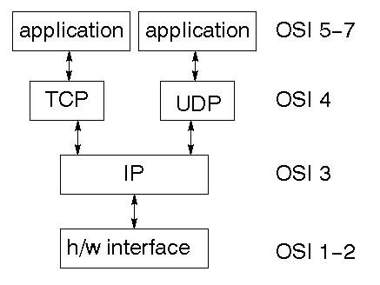
TCP is a connection-oriented protocol; UDP (User Datagram Protocol) is a connectionless protocol.

IP datagram’s
The IP layer provides a connectionless and unreliable delivery system. It considers each datagram independently of the others. Any association between datagram must be supplied by the higher layers. The IP layer supplies a checksum that includes its own header. The header includes the source and destination addresses. The IP layer handles routing through an Internet. It is also responsible for breaking up large datagram into smaller ones for transmission and reassembling them at the other end.

UDP
UDP is also connectionless and unreliable. What it adds to IP is a checksum for the contents of the datagram and port numbers. These are used to give a client/server model - see later.

TCP
TCP supplies logic to give a reliable connection-oriented protocol above IP. It provides a virtual circuit that two processes can use to communicate.

Internet addresses
In order to use a service, you must be able to find it. The Internet uses an address scheme for machines so that they can be located. The address is a 32 bit integer which gives the IP address. This encodes a network ID and more addressing. The network ID falls into various classes according to the size of the network address.

Network address
Class A uses 8 bits for the network address with 24 bits left over for other addressing. Class B uses 16 bit network addressing. Class C uses 24 bit network addressing and class D uses all 32.

Subnet address
Internally, the UNIX network is divided into sub networks. Building 11 is currently on one sub network and uses 10-bit addressing, allowing 1024 different hosts.

Host address
8 bits are finally used for host addresses within our subnet. This places a limit of 256 machines that can be on the subnet.

Total address

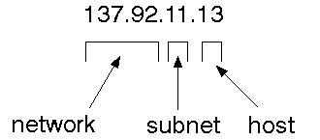
The 32 bit address is usually written as 4 integers separated by dots.

Port addresses
A service exists on a host, and is identified by its port. This is a 16 bit number. To send a message to a server, you send it to the port for that service of the host that it is running on. This is not location transparency! Certain of these ports are "well known".

Sockets
A socket is a data structure maintained by the system to handle network connections. A socket is created using the call socket. It returns an integer that is like a file descriptor. In fact, under Windows, this handle can be used with Read File and Write File functions.
#include <sys/types.h>
#include <sys/socket.h>
int socket(int family, int type, int protocol);
Here "family" will be AF_INET for IP communications, protocol will be zero, and type will depend on whether TCP or UDP is used. Two processes wishing to communicate over a network create a socket each. These are similar to two ends of a pipe - but the actual pipe does not yet exist.
Canvas Chart
JFreeChart is a free 100% Java chart library that makes it easy for developers to display professional quality charts in their applications. JFreeChart's extensive feature set includes:
A consistent and well-documented API, supporting a wide range of chart types;
A flexible design that is easy to extend, and targets both server-side and client-side applications;
Support for many output types, including Swing components, image files (including PNG and JPEG), and vector graphics file formats (including PDF, EPS and SVG);
JFreeChart is "open source" or, more specifically, free software. It is distributed under the terms of the GNU Lesser General Public Licence (LGPL), which permits use in proprietary applications.

1. Map Visualizations
Charts showing values that relate to geographical areas. Some examples include: (a) population density in each state of the United States, (b) income per capita for each country in Europe, (c) life expectancy in each country of the world. The tasks in this project include:
Sourcing freely redistributable vector outlines for the countries of the world, states/provinces in particular countries (USA in particular, but also other areas);
Creating an appropriate dataset interface (plus default implementation), a rendered, and integrating this with the existing XYPlot class in JFreeChart;
Testing, documenting, testing some more, documenting some more.

2. Time Series Chart Interactivity

Implement a new (to JFreeChart) feature for interactive time series charts --- to display a separate control that shows a small version of ALL the time series data, with a sliding "view" rectangle that allows you to select the subset of the time series data to display in the main chart.

3. Dashboards

There is currently a lot of interest in dashboard displays. Create a flexible dashboard mechanism that supports a subset of JFreeChart chart types (dials, pies, thermometers, bars, and lines/time series) that can be delivered easily via both Java Web Start and an applet.

4. Property Editors

The property editor mechanism in JFreeChart only handles a small subset of the properties that can be set for charts. Extend (or reimplement) this mechanism to provide greater end-user control over the appearance of the charts.

Tomcat 8.0 web server

Tomcat is an open source web server developed by Apache Group. Apache Tomcat is the servlet container that is used in the official Reference Implementation for the Java Servlet and Java Server Pages technologies. The Java Servlet and Java Server Pages specifications are developed by Sun under the Java Community Process. Web Servers like Apache Tomcat support only web components while an application server supports web components as well as business components (BEAs Web logic, is one of the popular application server).To develop a web application with jsp/servlet install any web server like JRun, Tomcat etc to run your application.
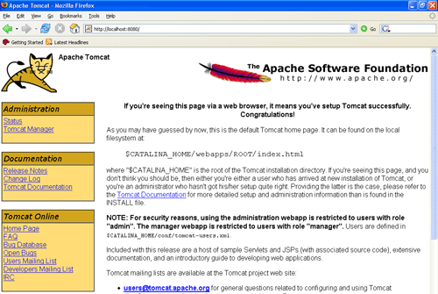

Fig: Tomcat Webserver

